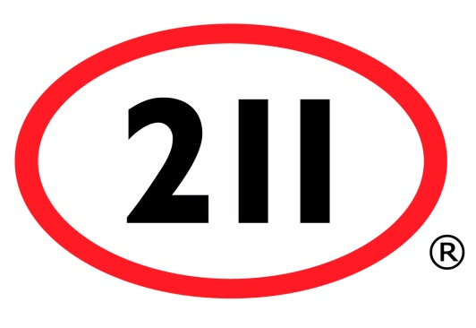

Windsor-Essex E-Blast Service
ORDER FORM

Announce changes in your organization and promote services, special celebrations, workshops and events.

Requested Date of E-Blast:

Optional: List additional information to include on your E-Blast (which will appear above your poster/flyer)

Billing Information*:

Authorized by:
Email:
Organization:
Address:
City:
Postal Code:
Phone:
PO Number (if applicable):

Cost: $88.50 + HST (City of Windsor HST #12413 5294 RT0001)

*An invoice from the City of Windsor (211 South West Regional Service Provider) will be sent to your organization within 5 business days

Service Includes:

- Customized E-Blast to over 600 organizations and 1000 contacts

- High impact and direct promotion of your information within our community:

- Business associations & groups
- Child care facilities
- Health care (hospitals & medical clinics)
- Long term care facilities (retirement & nursing homes, continuing care services)
- Media (radio, newspaper, television, local magazines)

- Places of worship
- Government services (federal departments and agencies, provincial ministries and agencies) and elected officials

- Boards of education
- Major non-profit organizations

How To Order:

- Complete this form and e-mail it along with an electronic version of your document and/or link to info@211southwestontario.ca

- Accepted formats: Word, PDF, PNG, JPG, and GIF (up to 1 MB) and web links.

- Two-page limit for event notices such as posters and flyers, in accepted format. A web link is required for more lengthy or detailed information.
(211 reserves the right to approve submission and content format)

- Return completed Order Form at least 2 weeks prior to requested date of E-Blast.

QUESTIONS? info@211southwestontario.ca

